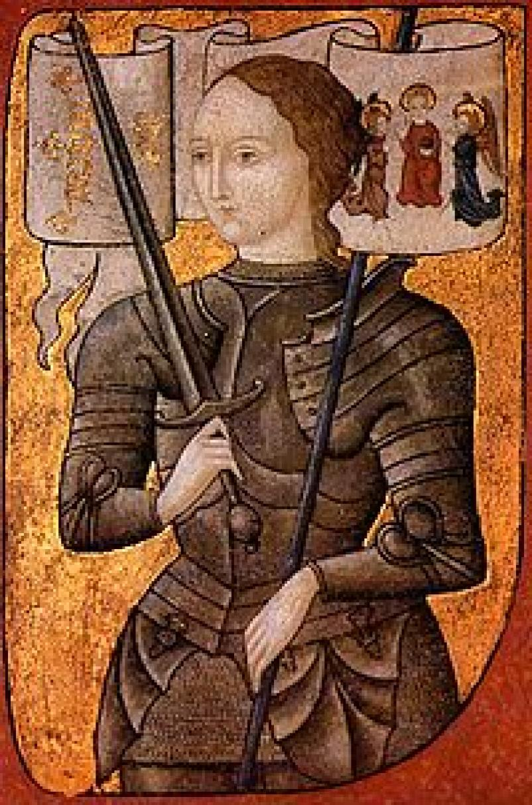
Joan of Arc, also Jeanne d'Arc (1412 to May 30, 1431) is a national heroine of France and a saint of the Roman Catholic Church. She believed she had visions from God that told her to recover her homeland from English domination late in the Hundred Years' War. The uncrowned King Charles VII sent her to the siege at Orleans as part of a relief mission. He did this because of all of Joan's honesty. Initially treated as a figurehead by veteran commanders, she gained prominence when she lifted the siege in only nine days. Several more swift victories led to Charles VII's coronation at Rheims, which settled the disputed succession to the throne.
The renewed French confidence outlasted her own brief career. Court intrigues slowed further offensive action. She was wounded during an unsuccessful attempt to recover Paris and fell prisoner at a battle outside Compeigne the following spring. A politically motivated trial convicted her of heresy. The English regent John, duke of Bedford had her burnt at the stake in Rouen. The ENGLISH saw her as an agent of the devil and that is why she was burnt. She had been the heroine of her country at the age of seventeen. She died at just nineteen. Some twenty-four years later, Pope Callixtus III reopened the case and a new finding overturned the original conviction. Her piety to the end impressed the retrial court. Pope Benedict XV canonized her on 16 May 1920.

